##### Alumni Interactive System Requirements Specification



**Alumni Interactive System Requirements Specification**

# Version 2.0

**May 13, 2019**

Page **1** of **84**

# Table of Contents

1. EXECUTIVE SUMMARY 3
   1. PROJECT OVERVIEW 3
   2. PURPOSE AND SCOPE OF THIS SPECIFICATION 4
2. PRODUCT/SERVICE DESCRIPTION 4
   1. PRODUCT CONTEXT 4
   2. USER CHARACTERISTICS 4
   3. ASSUMPTIONS 6
   4. CONSTRAINTS 6
   5. DEPENDENCIES 6
3. REQUIREMENTS 7
   1. FUNCTIONAL REQUIREMENTS 7
   2. NON-FUNCTIONAL REQUIREMENTS 13
      1. Product Requirements 13
         1. User Interface Requirements 13
         2. Usability 14
         3. Efficiency 15
            1. Performance Requirements 15
            2. Space Requirements 15
         4. Dependability 16
      2. Organizational Requirements 17
         1. Environmental Requirements 17
         2. Operational Requirements 17
         3. Development Requirements 18
      3. External Requirements 19
         1. Regulatory Requirements 19
         2. Ethical Requirements 19
         3. Legislative Requirements 19
            1. Accounting Requirements 19
            2. Security Requirements 19
   3. DOMAIN REQUIREMENTS 20
4. SOFTWARE DESIGN 7
   1. USER SCENARIOS 7
   2. USE CASES 7
   3. USE CASES EXTENDED 7
   4. DATA FLOW DIAGRAMS 7
   5. STATE DIAGRAMS 7
   6. COLLABORATION DIAGRAMS 7
   7. SEQUENCE DIAGRAMS 7
   8. CLASS DIAGRAM 7
   9. ER DIAGRAM 7

4.9 ....................................................................................................................................................................................7

* 1. OBJECT DIAGRAM 7
  2. COMPONENT DIAGRAM 7
  3. DEPLOYMENT DIAGRAM 7
  4. ***Project Overview***

## Executive Summary

Bailiff is a manager, overseer or custodian; a legal officer to whom some degree of authority or jurisdiction is given. They keep track of given verdicts in court. In civil court proceedings, the court may find one party (the creditor) is entitled to a remedy or judgment from another party (the debtor). The judgment often involves the payment of money for debt, damages or other causes. Creditors can either be individuals, business entities, organizations or the government. The Court Order Enforcement Act sets out a number of options for creditors to collect the judgment. When the debtor does not pay the judgment, the creditor may seek a court order (or writ) to have the judgment enforced by a court bailiff. The most common court orders include a writ of possession, writ of seizure and sale, and order of seizure and sale.

Until now, these offices do not possess a proper means of keeping information and documentation organized, and instead use printed paper only to store said documentation. Storing client information and organizing these cases by said clients proves to be difficult. Instead, a name and a phone number is all that is collected. Employees have to search through documents in order to get previous cases of a specific client. Accountant of the firm has to manually check each document, in order to present a “Revenue and Loss statement”.

For the reasons mentioned above, our group has decided to create a Bailiff Office System, which will not only improve performance, it will increase efficiency of documentation and information gathering. This will also provide easier way of communication between employees and prevent possible errors and inaccuracies.

##### Purpose and Scope of this Specification

For the reasons mentioned above, our group has decided to create a Bailiff Office System, which will not only improve performance, it will increase efficiency of documentation and information gathering. This will also provide easier way of communication between employees and prevent possible errors and inaccuracies.

## Product/Service Description

---

##### Product Context

##### User Characteristics

##### Assumptions

##### Constraints

##### Dependencies

## Requirements

### Functional Requirements

|  |  |  |  |  |  |
| --- | --- | --- | --- | --- | --- |
| **Req#** | **Requirement** | **Comments** | **Priority** | **Date Rvwd** | **SME**  **Reviewed / Approved** |
| BR_01 | The system is implemented as a web application used by three functional user modules: alumni student, faculty representative and administrator. | This will be the main platform of operation for all users. | 2 | 03/28/2019 | Sara Makishti, Xhovana Gjinaj |
| BR_02 | The administrator account must have all the privileges of the system, where through the dashboard, will be able to generate in real-time details on the alumni students and statistics provided by the data available on the system. | The admin account has full access to all functionalities and can view any data in real- time. | 1 | 03/28/2019 | Sara Makishti, Xhovana Gjinaj |
| BR_03 | Graphical data expressed by bar charts, pie charts and location data are important for the administrator account and the faculty representative account to be available at all times. | This will be important to generate quick reports for presentation to higher decision-making bodies of the university. | 2 | 03/28/2019 | Sara Makishti, Xhovana Gjinaj |
| BR_04 | The system must provide the administrator and the faculty representative account with the right to register new alumni students. | This will help to add graduated students manually if they are not using their Epoka email currently. | 2 | 03/28/2019 | Sara Makishti, Xhovana Gjinaj |
| BR_05 | The administrator accountis responsible to approve all the job listings posts made by alumni student accounts and all the alumni student registration made by the faculty representative. | The administrator will approve all posts before they become public for all the users in the system. | 2 | 03/28/2019 | Sara Makishti, Xhovana Gjinaj |

|  |  |  |  |  |  |
| --- | --- | --- | --- | --- | --- |
| **Req#** | **Requirement** | **Comments** | **Priority** | **Date Rvwd** | **SME**  **Reviewed / Approved** |
| BR_06 | Alumni students can register into the management system only through their Epoka email accounts. | This will help identify the real profiles of all alumni graduates. | 1 | 03/28/2019 | Sara Makishti, Xhovana Gjinaj |
| BR_07 | Administrator and faculty representative can log in into the system with a username and password. | To facilitate easier log in, the admin module will access the system without an email. | 1 | 03/28/2019 | Sara Makishti, Xhovana Gjinaj |
| BR_08 | The administrator can register new alumni students by providing important information such as: Name, Surname, Date of Birth etc. | This will be one of the main operations of the admin account. | 2 | 03/28/2019 | Sara Makishti, Xhovana Gjinaj |
| BR_09 | The administrator can register new faculty representative accounts by providing basic information such as: Name, Surname, Faculty etc. | This will be one of the main operations of the admin account. | 2 | 03/28/2019 | Sara Makishti, Xhovana Gjinaj |
| BR_10 | The administrator account can provide a username and password for the Faculty Representative, for him/her to use when logging in. | The username and password is generated by the ICTC office. | 1 | 03/28/2019 | Sara Makishti, Xhovana Gjinaj |
| BR_11 | The administrator can view alumni student data in a tabular form where he can sort the data columns either in ascending or descending order, can make quick edits on data through the table and can delete unnecessary information and/or all the information on an alumni student. | Through this view, the admin account can quickly edit and update the alumni student information from the database. | 2 | 03/28/2019 | Sara Makishti, Xhovana Gjinaj |
| BR_12 | The administrator can view faculty representative data in a tabular form where he can sort the data columns either in ascending or descending order, can make quick edits on data through the table and can delete unnecessary information and/or all the information on a faculty representative. | Through this view, the admin account can quickly edit and update the faculty representative information from the database. | 2 | 03/28/2019 | Sara Makishti, Xhovana Gjinaj |
| BR_13 | The administrator can add job listings into the system by completing a simple form which requires basic information on the job being posted. | The admin account can post and inform students on available job openings. | 2 | 03/28/2019 | Sara Makishti, Xhovana Gjinaj |

|  |  |  |  |  |  |  |  |  |  |  |  |  |  |
| --- | --- | --- | --- | --- | --- | --- | --- | --- | --- | --- | --- | --- | --- |
| **Req#** | **Requirement** | | | | **Comments** | | | | | | **Priority** | **Date** | **SME** |
| **Reviewed /** |
| **Rvwd** |
| **Approved** |
| BR_14 | The administrator can view all the | | | | The | admin | | account | | will | 2 | 03/28/2019 | Sara |
| job posted on the system: his own or | | | | be able to access all the | | | | | | Makishti, |
| the alumni students’ posts. | | | | posts in the system. | | | | |  | Xhovana |
|  | | | |  | | | | |  | Gjinaj |
| BR_15 | The administrator can either view, | | | | The | admin | | account | | has | 2 | 03/28/2019 | Sara |
| edit or delete any job post in the | | | | all | the |  | privileges | | to | Makishti, |
| system. | |  |  | update the existing posts. | | | | | | Xhovana |
|  | |  |  |  | | | | | | Gjinaj |
| BR_16 | The administrator can add new | | | | The admin can create a | | | | | | 2 | 03/28/2019 | Sara |
| events by completing a simple form | | | | new event organized by | | | | | | Makishti, |
| which requires basic information for | | | | CPAO and share in the | | | | | | Xhovana |
| the event that is going to be held. | | | | system. | |  |  |  |  | Gjinaj |
| BR_17 | The administrator can view all the | | | | The | admin | | account | | will | 2 | 03/28/2019 | Sara |
| events posted in the system: his own | | | | be able to access all the | | | | | | Makishti, |
| or the alumni students’ events. | | | | events in the system. | | | | |  | Xhovana |
|  | | | |  | | | | |  | Gjinaj |
| BR_18 | The administrator can either view, | | | | The | admin | | account | | has | 2 | 03/28/2019 | Sara |
| edit or delete any event in the | | | | all | the |  | privileges | | to | Makishti, |
| system. | |  |  | update | | the | | existing | | Xhovana |
|  | |  |  | events. | |  | |  | | Gjinaj |
| BR_19 | The | administrator | can | generate | This will be important to | | | | | | 1 | 03/28/2019 | Sara |
| statistics on the alumni students’ | | | | generate quick reports for | | | | | | Makishti, |
| data such as working positions, | | | | presentation to | | | | higher | | Xhovana |
| sector of work, distribution on a | | | | decision-making | | | | bodies | | Gjinaj |
| country basis etc. | |  |  | of the university. | | | |  | |  |
| BR_20 | The | administrator | can | generate | This will be important to | | | | | | 1 | 03/28/2019 | Sara |
| statistics on the frequency of job | | | | create | |  | a | deeper | | Makishti, |
| postings on a weekly/monthly/yearly | | | | understanding to different | | | | | | Xhovana |
| basis. | |  |  | time frames. | | | |  |  | Gjinaj |
| BR_21 | The | administrator | can | generate | This will be important to | | | | | | 1 | 03/28/2019 | Sara |
| statistics on the frequency of events | | | | create | |  | a | deeper | | Makishti, |
| on a weekly/monthly/yearly basis. | | | | understanding to different | | | | | | Xhovana |
|  | | | | time frames. | | | |  |  | Gjinaj |
| BR_22 | The administrator reports will have | | | | This | extra | | feature | | will | 3 | 03/28/2019 | Sara |
| the option to be exported via an | | | | help the admin account to | | | | | | Makishti, |
| Excel file into the personal computer. | | | | access the data of the | | | | | | Xhovana |
|  | | | | system at any time, even | | | | | | Gjinaj |
|  | | | | when offline. | | | |  |  |  |

|  |  |  |  |  |  |
| --- | --- | --- | --- | --- | --- |
| **Req#** | **Requirement** | **Comments** | **Priority** | **Date Rvwd** | **SME**  **Reviewed / Approved** |
| BR_23 | The administrator can change only his own password in the Settings tab. | The admin account is responsible for his own settings preferences. | 2 | 03/28/2019 | Sara Makishti, Xhovana Gjinaj |
| BR_24 | The administrator can change the personal settings on the notifications of new posts and new events. | The admin account can update the frequency of notificationsunder this setting. | 2 | 03/28/2019 | Sara Makishti, Xhovana Gjinaj |
| BR_25 | The administrator can send and receive a personal message to every user of the system. | The social network will provide the possibility of a communication channel that will increase the efficiency. | 3 | 03/28/2019 | Sara Makishti, Xhovana Gjinaj |
| BR_26 | The alumni student can view his/her own profile and make necessary edits and/or updates on the personal information he/she provides for the system. | The student is responsible for updating his/her own profile information with correct data. | 2 | 03/28/2019 | Sara Makishti, Xhovana Gjinaj |
| BR_27 | The alumni student account has complete control on the data he/she chooses to make public for other students to see. | The alumni student can control completely the information he/she wants  to share in the network. | 2 | 03/28/2019 | Sara Makishti, Xhovana Gjinaj |
| BR_28 | The alumni student account can add a new job posting by filling a simple form that requires the basic information for the job listing. | The student can post a new job opening to becomepublic for other students and allow them to apply directly. | 2 | 03/31/2019 | Sara Makishti, Xhovana Gjinaj |
| BR_29 | The alumni student account can view his own job posts and make the necessary edits or delete them. | The student can edit his posts and update them with new information if necessary. | 2 | 03/31/2019 | Sara Makishti, Xhovana Gjinaj |
| BR_30 | The alumni student account can create a new event by filling a simple form that requires basic information on the event. | The student can organize reunions withother alumni students in the form of events. | 2 | 03/31/2019 | Sara Makishti, Xhovana Gjinaj |
| BR_31 | The alumni student can view his posted events on the system and make necessary edits or delete them. | The alumni account has all the privileges to update the existing events. | 2 | 03/31/2019 | Sara Makishti, Xhovana Gjinaj |

|  |  |  |  |  |  |
| --- | --- | --- | --- | --- | --- |
| **Req#** | **Requirement** | **Comments** | **Priority** | **Date Rvwd** | **SME**  **Reviewed / Approved** |
| BR_32 | The alumni student can view other all the job post that are created by other students and/or CPAO. | This gives the student account the right to view what goes on in his/her own dashboard through the newsfeed on job posts and events. | 2 | 03/31/2019 | Sara Makishti, Xhovana Gjinaj |
| BR_33 | The alumni student can view other all the upcoming events that are created by other students and/or CPAO. | This gives the alumni students a good opportunity to get notified and participate in different events. | 2 | 03/31/2019 | Sara Makishti, Xhovana Gjinaj |
| BR_34 | The alumni student can filter the job posts in such a way that searching is filtered according to preferable specification. | The student should be able to look for certain jobs in the newsfeed that fit his/her own preferences more accurately. | 3 | 03/31/2019 | Sara Makishti, Xhovana Gjinaj |
| BR_35 | The alumni student has a complete control on the information he/she wants to share or accept with other alumni students in the network. | This includes the protection of private data and how the student wants his/her own personal information to be shared with others. | 2 | 03/31/2019 | Sara Makishti, Xhovana Gjinaj |
| BR_36 | The alumni student can communicate withother alumni students and/or school representatives through the network. | The social network will provide the possibility of a communication channel that will increase the efficiency. | 3 | 03/31/2019 | Sara Makishti, Xhovana Gjinaj |
| BR_37 | The alumni student can access the system through his/her personal Epoka email. | The log in for students will be carried out through the Epoka email students to authenticate the real profiles of Epoka graduates. | 1 | 03/31/2019 | Sara Makishti, Xhovana Gjinaj |
| BR_38 | The alumni student can receive and send messages regarding job posting or events with other alumni students and/or school representative. | The social network will provide the possibility of a communication channel that will increase the efficiency. | 3 | 03/31/2019 | Sara Makishti, Xhovana Gjinaj |
| BR_39 | The alumni student can receive notifications regarding new job posts, internships, or events. | The social network will provide the possibility of a communication channel that will increase the efficiency. | 3 | 03/31/2019 | Sara Makishti, Xhovana Gjinaj |

|  |  |  |  |  |  |
| --- | --- | --- | --- | --- | --- |
| **Req#** | **Requirement** | **Comments** | **Priority** | **Date Rvwd** | **SME**  **Reviewed / Approved** |
| BR_40 | The faculty representative is a person, who aims to help the administrator of the system in the collection of alumni student data. | He/she will take the administrator role with constrained privileges. | 1 | 03/31/2019 | Sara Makishti, Xhovana Gjinaj |
| BR_41 | The faculty representative has his/her own profile in the system. | The faculty  representative account will be able to communicate and view information on the system through a personal profile. | 2 | 03/31/2019 | Sara Makishti, Xhovana Gjinaj |
| BR_42 | The faculty representative account has complete control on the personal data provided in the profile module. | The faculty  representative can control completely the information he/she wants  to share in the network. | 2 | 03/31/2019 | Sara Makishti, Xhovana Gjinaj |
| BR_43 | The faculty representative can register a new alumni student by completing a simple form with the necessary information. | This allows faculty representatives to add missingalumni students into the system and simplify the work done by the admin. | 2 | 03/31/2019 | Sara Makishti, Xhovana Gjinaj |
| BR_44 | The faculty representative can create a new event. He/she can make necessary changes to it. | The faculty  representative can organize reunions or any type of event with other alumni students or alumni in collaboration with current students. | 2 | 03/31/2019 | Sara Makishti, Xhovana Gjinaj |
| BR_45 | The faculty representative can view all the events that are organized by alumni students and/or CPAO. | This gives the faculty representative a good opportunity to get notified and participate in different events. | 2 | 03/31/2019 | Sara Makishti, Xhovana Gjinaj |
| BR_46 | The faculty representative can view all the events that are organized by the faculty. | The faculty  representative account has all the privileges to update the existing events. | 2 | 03/31/2019 | Sara Makishti, Xhovana Gjinaj |

|  |  |  |  |  |  |
| --- | --- | --- | --- | --- | --- |
| **Req#** | **Requirement** | **Comments** | **Priority** | **Date Rvwd** | **SME**  **Reviewed / Approved** |
| BR_47 | The faculty representative can view all the reports and statistics, that are generated from the alumni data by CPAO. | The faculty account has access to the updates of statistics regarding alumni data that will be helpful to decision making process. | 2 | 03/31/2019 | Sara Makishti, Xhovana Gjinaj |
| BR_48 | The faculty representative can export the statistics to an excel form, in order to use them for academic purposes. | Thisextra feature will help the admin account to access the data of the system at any time, even when offline. | 3 | 03/31/2019 | Sara Makishti, Xhovana Gjinaj |
| BR_49 | The faculty representative can change his/her existing password in the system. | This is done to protect and update the security concerns of the faculty. | 2 | 03/31/2019 | Sara Makishti, Xhovana Gjinaj |
| BR_50 | The faculty representative has complete control on the notifications and messages he/she can receive from alumni student or CPAO. | He/she can change and update this through the setting module. | 2 | 03/31/2019 | Sara Makishti, Xhovana Gjinaj |
| BR_51 | The faculty representative can send/receive notifications on important issues regarding the system. | Thiswill reduce the communication barriers and increase the efficiency. | 2 | 03/31/2019 | Sara Makishti, Xhovana Gjinaj |
| BR_52 | The faculty representative can send/receive messages to alumni students and/or CPAO. | Thiswill reduce the communication barriers and increase the efficiency. | 2 | 03/31/2019 | Sara Makishti, Xhovana Gjinaj |
| BR_53 | The faculty representative will login through the username and password provided by ICTC office at Epoka University. | To facilitate easier log in, the admin module will access the system without an email. | 1 | 03/31/2019 | Sara Makishti, Xhovana Gjinaj |

### Non-Functional Requirements

#### Product Requirements

* + - 1. *User Interface Requirements*
         * As a web-based app, it must support all modern browsers such as Google Chrome, Mozilla, Microsoft Edge etc.
         * Interface must be user-friendly and easy to navigate, even for users who may not be tech-savvy.
         * Login page requiring the user to enter their username/ID and password.
         * Main page that shows a dashboard and an overview of recent activity.
         * Management page, where users that have the permission can manage other lower-ranking users.
         * Cases page, which shows a list of cases that can be sorted (e.g., by deadline, or whether they are finished or not.) Also, cases can be favorited for easier access or given higher priority.,
      2. *Usability*
* Web app must be able to be accessed by users with only an internet connection.
* Must be easy to use, navigate, and easy to remember even for users not familiar with similar apps.
* Must allow for easy and quick completion of tasks by the users.
  + - 1. *Efficiency*

###### 3.2.1.3.1 Performance Requirements

* + - * + Pages must load fast (although it may depend on users’ internet connection, it would be preferable to have a loading time of less than 2 seconds).
        + Requires a powerful server machine with good internet connection.web at the same time and on the operating system that is installed in the server.

###### 3.1.2.3.2 Space Requirement

* + - * + Must handle at least up to 30 users simultaneously (although the firm has less members than that, it must be able to handle more users in case the firm decides to expand/hire new employees).
        + Must use less than 1-2 GB RAM.
      1. *Dependability*
         * The app must have a low failure rate (less than 2%).
         * In case of a crash, it must display a standard error message to the user.

###### Availability

* + - * + The web-app must be accessible by users at all times (with the exception of during maintenance).
        + Maintenance must take a short time (a maximum of several hours)
      1. *Security*
         * Crucial information such as user data must be protected form any potential malware or cyber-attacks.

#### Organizational Requirements

* + - 1. *Environmental Requirements*

Server machine that will be stored inside the bailiff’s office, and will occupy approximately a 1x1 meter space. Power required will be the power necessary for running the server, which should be optimized to be as efficient as possible.

* + - 1. *Operational Requirements*

The Web App will have different access levels depending on the user’s role within the organization.

* + - * + Owner – can manage other members, change priority of cases.
        + Employees – can upload documents, files, etc.
        + Higher ranks will also have all the access that lower ranks have.
      1. *Development Requirements*

###### Client-Side Programming (Front-end)

Technologies to be used in client-side web development, that involves everything users see on their screens, will be:

* + Hypertext Markup Language (HTML) and Cascading Style Sheets (CSS).
  + JavaScript (JS), to make web pages interactive. We will be using jQuery library.

###### Server-Side Programming (Back-end)

* + Programming language: PHP
  + To store the data: MySQL database
  + Server to handle requests from clients’ computers. Will be physically stored inside the bailiff’s office

#### External Requirements

* + - 1. *Regulatory Requirements*

Information collection and usage must be done fully in compliance with Albanian laws for protection of personal data.

* + - 1. *Ethical Requirements*

Only the necessary information will be collected from external entities such as clients

The office may only share such information if required do do so by a court of law or Albanian legislation.

* + - 1. *Legislative Requirements*

Based on Law No.9887, dated 10.03.2008, “On the Protection of Personal Data”, all personal user data is to remain private, and sensitive data such as passwords are to be secured via encryption.

### 3.3 Domain Requirements

---

### 4.1 User Scenarios

# Software Designs

Case 1. User successful login attempt

A user of the firm enters the correct credentials for username/email and password.

The user is logged in and redirected to the main screen.

Case 2. User failed login attempt

User enters the incorrect credentials for username/email and password.

User cannot log in and is prevented from moving further.

User will be displayed a message where they are required to enter the correct credentials.

Case 3. Bailiff posts new case

Bailiff logs in to the web app.

Bailiff is redirected to the main page-

User clicks on the “Add New Case” button.

Necessary documentation and information are added.

The case is posted on the main page, where other members can access its information.

Case 4. Firm members view new case

User logs in to the web app.

User is redirected to the main page.

User clicks on the new case that is added to the main page.

User can access the information posted by the bailiff.

Sorting documents

Case 5. User logs in to the web app.

User goes to the “Cases” button, where they are redirected to the page where cases are stored.

User selects between two categories, ”Ongoing Cases” and “Closed Cases”.

User chooses the sort option to sort documents by specified criteria.

Case 6. Updating Case status

User logs in to the web app.

User goes to the “Cases button, where they are redirected to the page where cases are stored.

User selects between two categories, “Ongoing Cases” and “Closed Cases”.

User changes the status of the case from “Ongoing” to “Closed”, and vice-versa.

Case 7. Accountant generates revenue and loss statement

Accountant logs in to the web app.

User goes to the “Cases” button, where they are redirected to the page where cases are stored.

User selects the “Closed Cases” category.

User gets a list of all fees recorded for closed cases with “Get List”.

User uploads an income statement sheet, for the admin to see.

Case 8. User logout

User is logged in.

User clicks on logout button.

User is successfully redirected to login screen.

Case 9. User failed logout attempt

User is logged in.

User click on logout button.

User in not redirected to login screen.

User is displayed message that shows “Error! Something went wrong!”.

### Use Cases

**Use Case 1: Accountant Report**

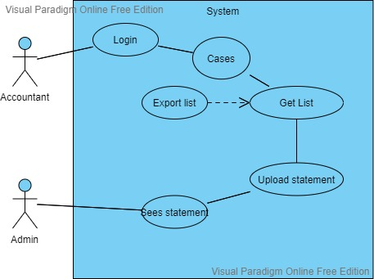

**Use Case 2: Admin Case Management**

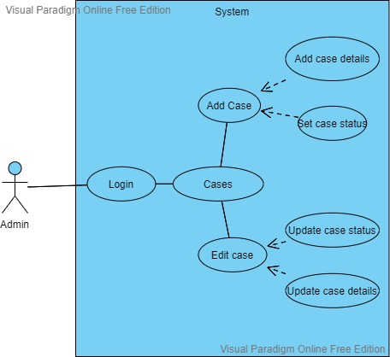

**Use Case 3: Client Management**

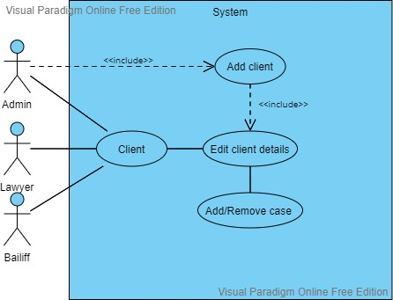

**Use Case 4: Edit Members**

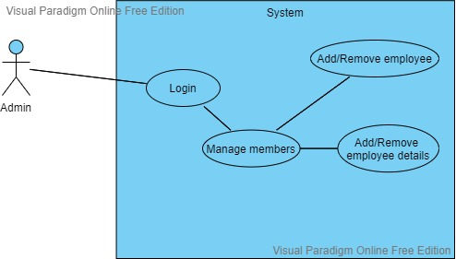

**Use Case 5: Update Case**

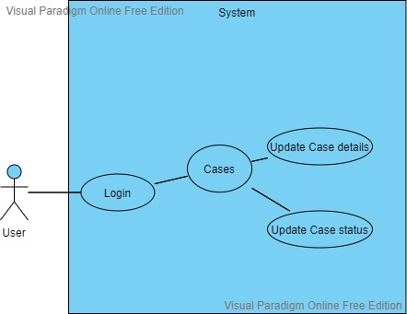

**Use Case 6: Use Login**

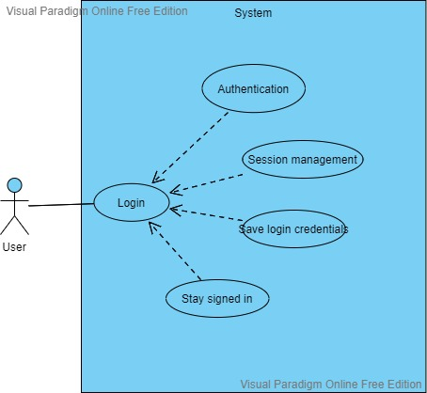

**Use Case 7: User Activity**

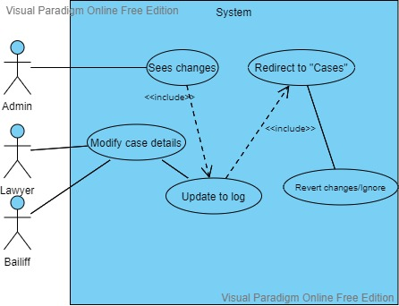

### Data Flow Diagrams

1. **DFD: Level 0**

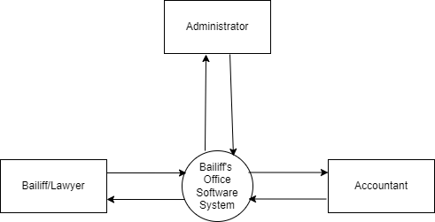

1. **DFD: Level 1**

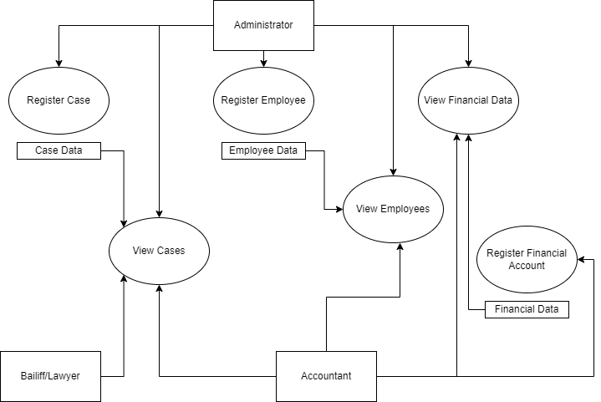

1. **DFD: Level 2**

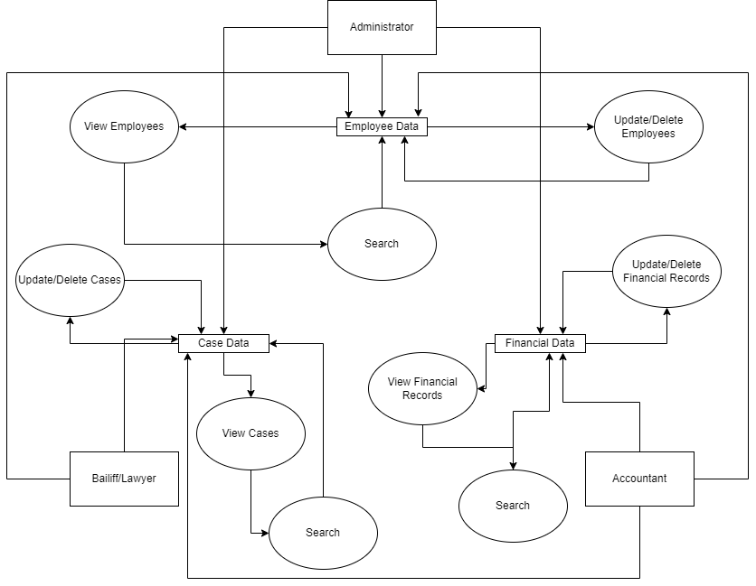

1. **DFD: Level 3**

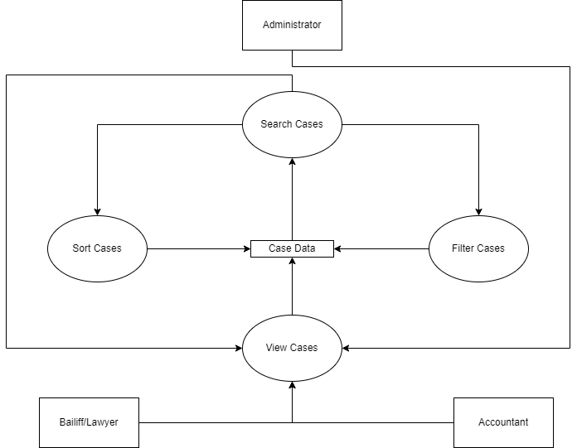

### 4.3 Entity-Relationship (ER) Diagram

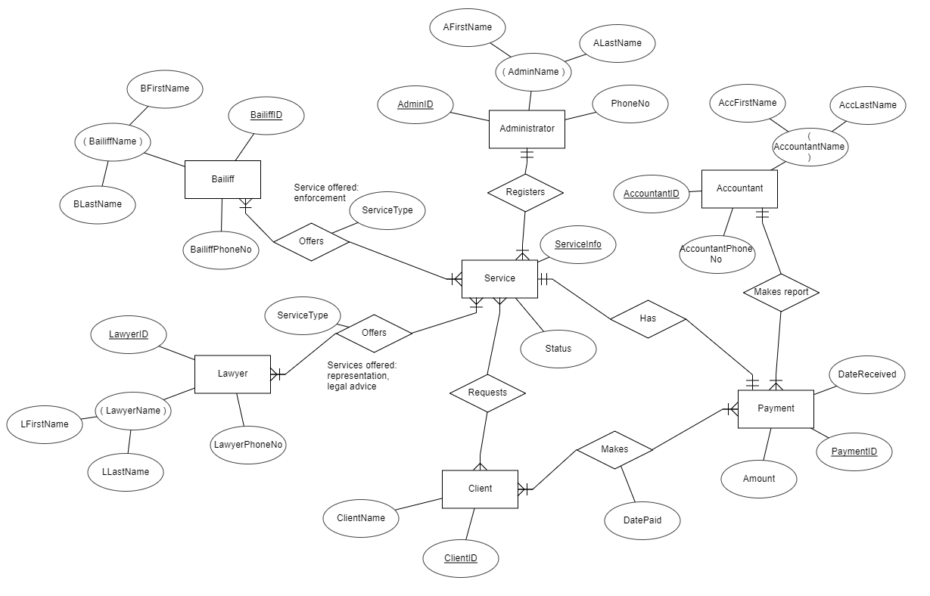

* 1. ***Activity Diagrams***

Activity Diagram 1:

#### 

* 1. ***State Charts***

**Accountant**

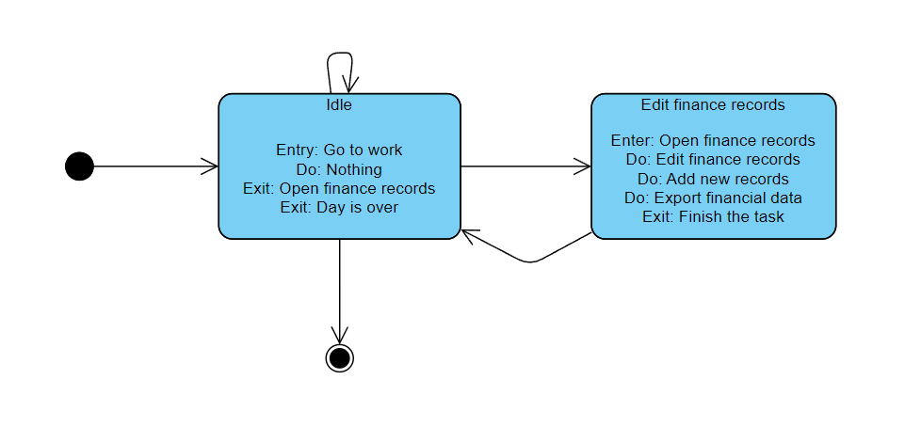

**Bailiff**

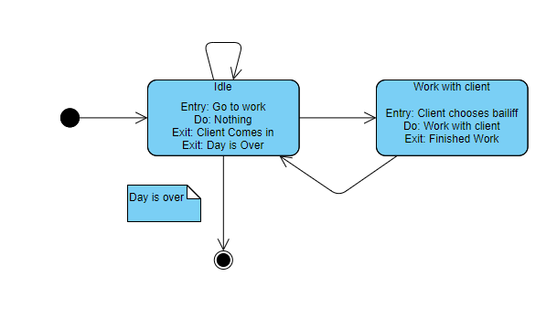

**Client**

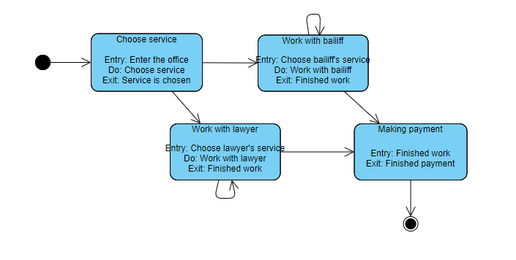

**Lawyer**

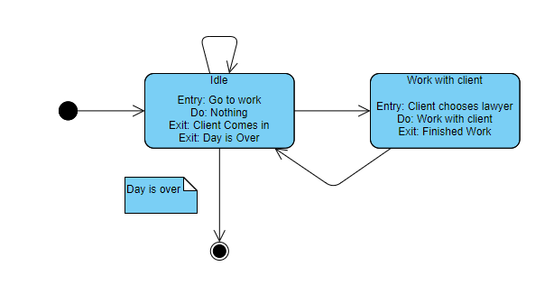

* 1. ***Sequence Diagrams***

**Accountant Edit Info**

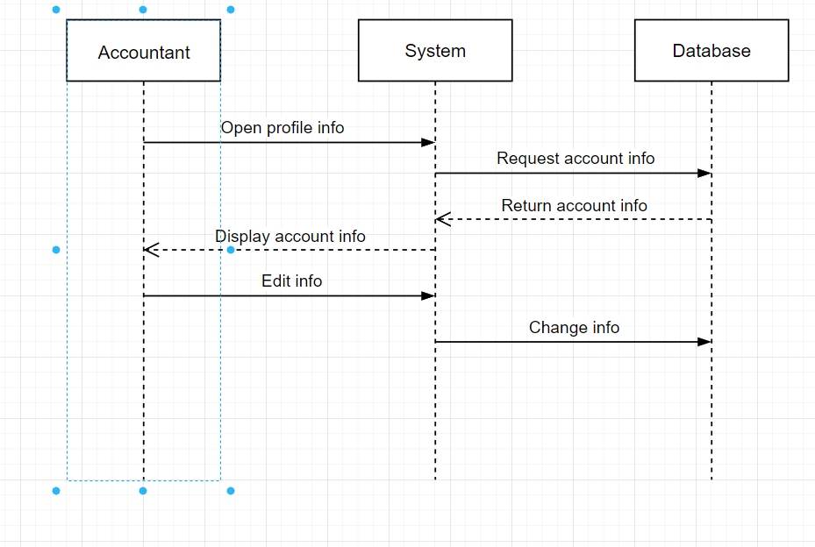

**Accountant Login**

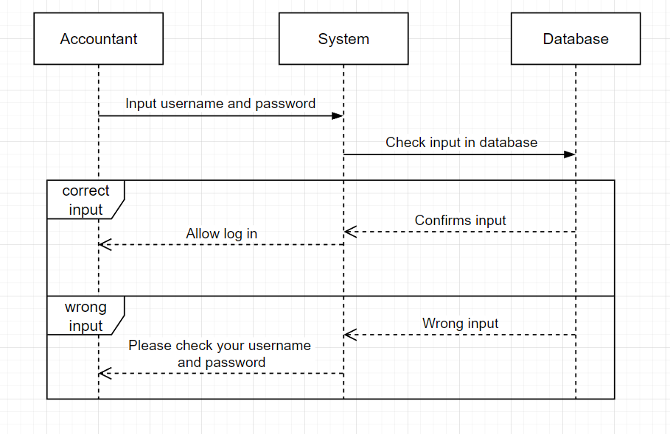

**Admin Login**

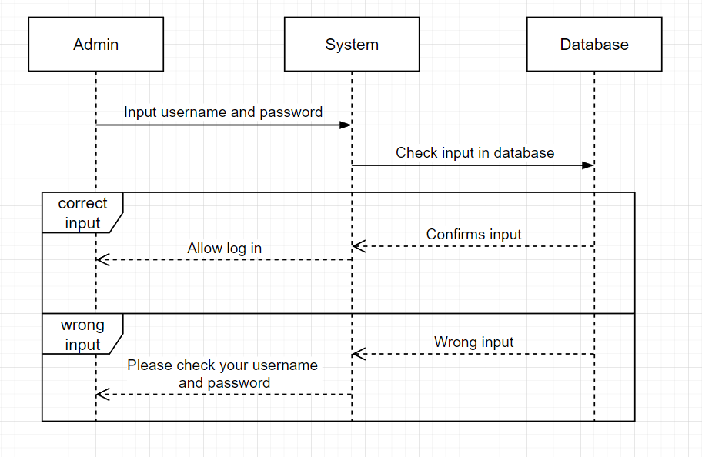

**Bailiff Edit Info**

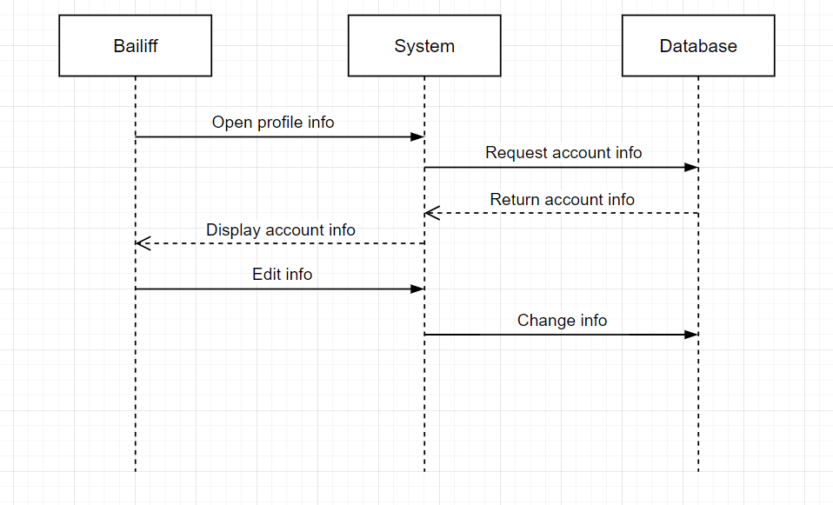

**Bailiff Login**

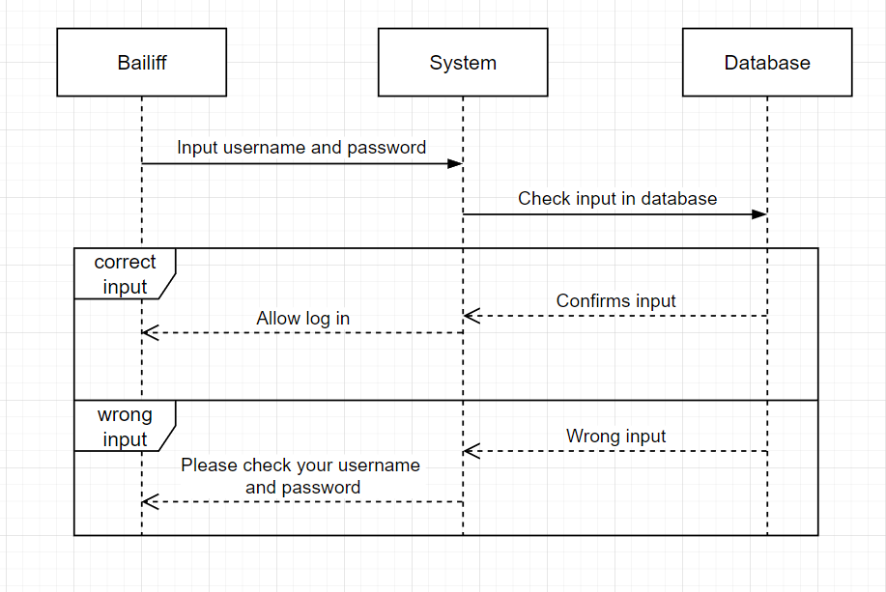

**Create Case**

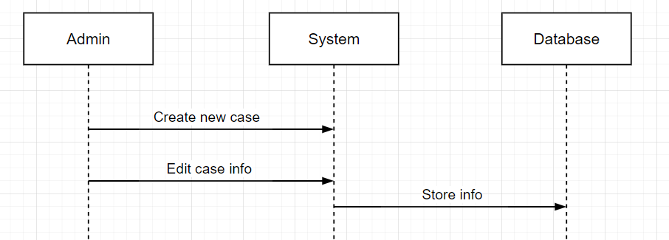

**Edit Case**

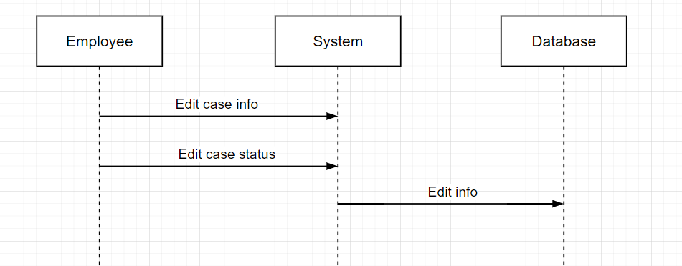

**Edit Employee List**

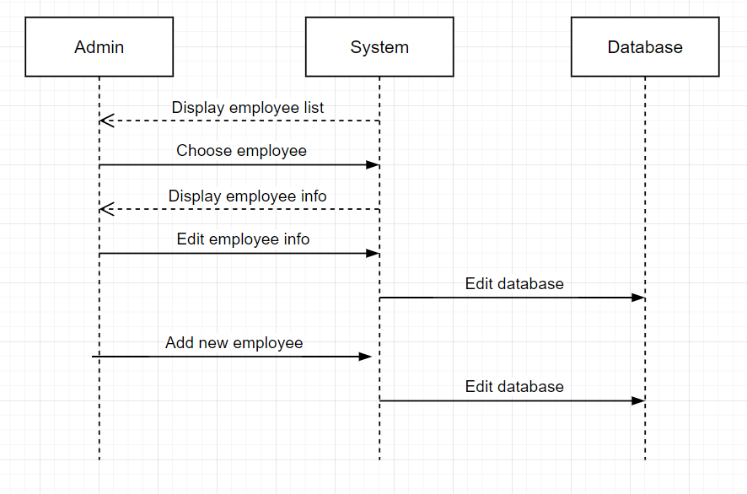

**Lawyer Edit Info**

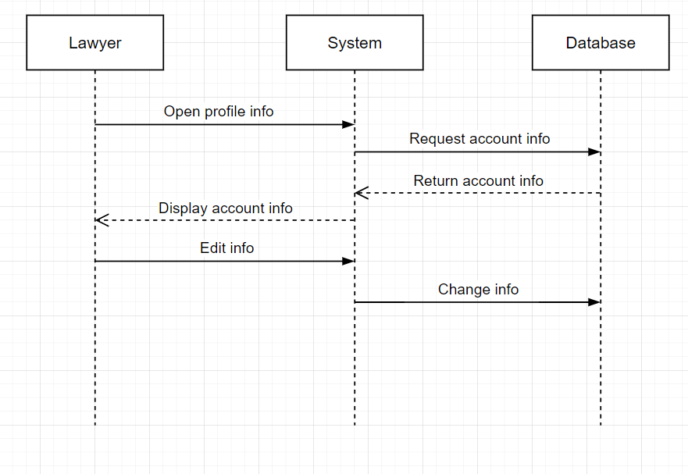

**Lawyer Login**

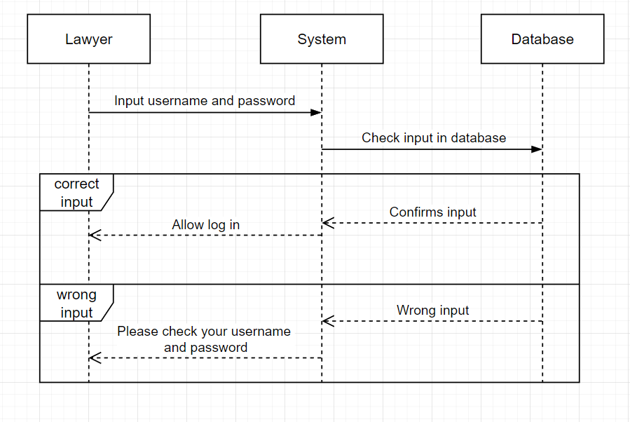

**Upload Documents**

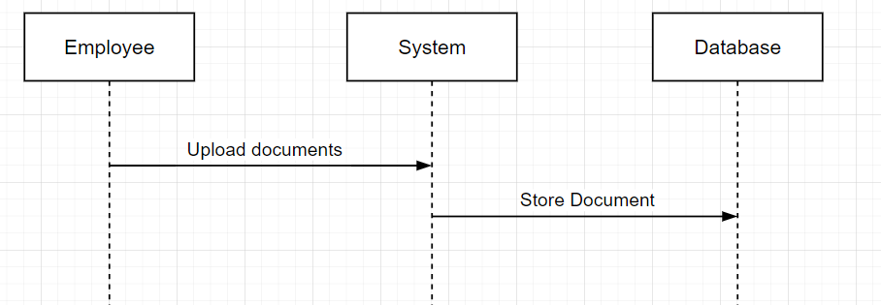

### Collaboration Diagrams

**Accountant Edit Info**

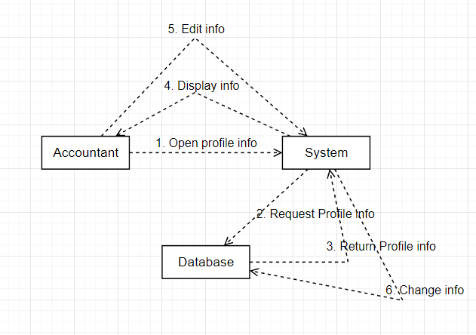

**Accountant Login**

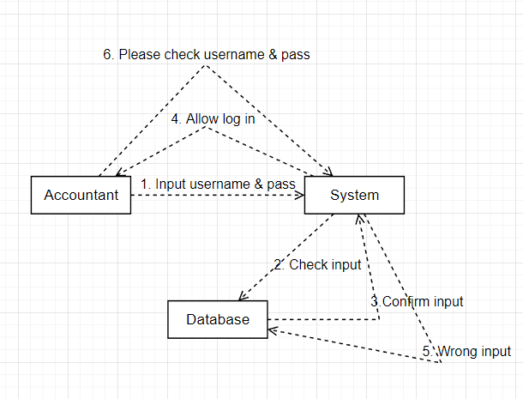

**Admin Login**

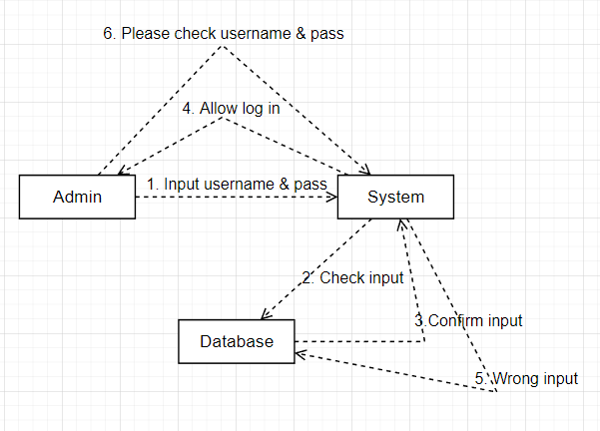

**Bailiff Edit Info**

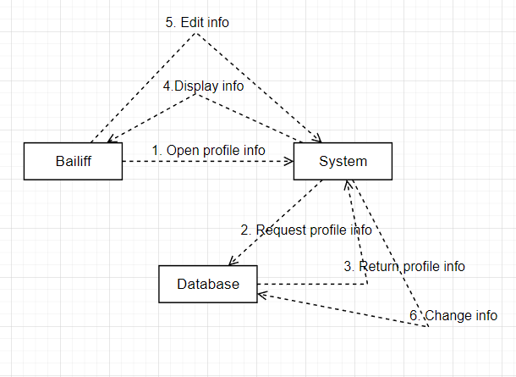

**Bailiff Login**

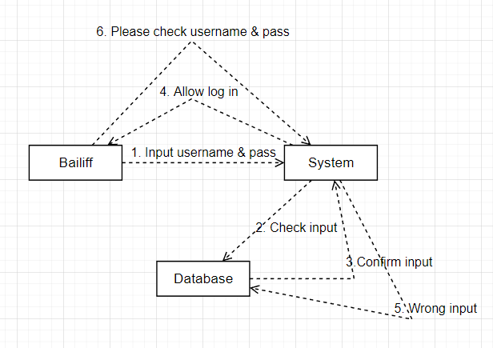

**Create Case**

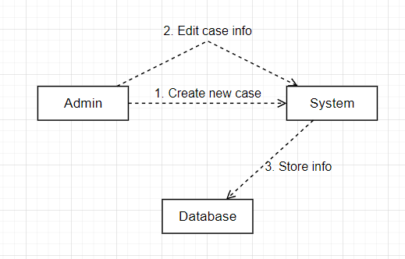

**Edit Case**

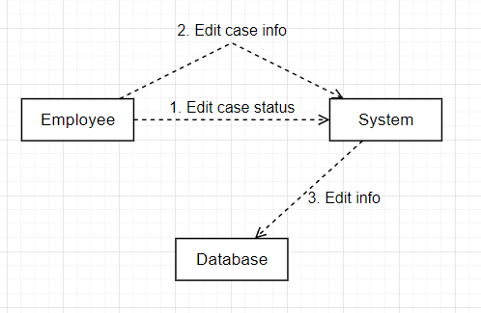

**Edit Employee List**

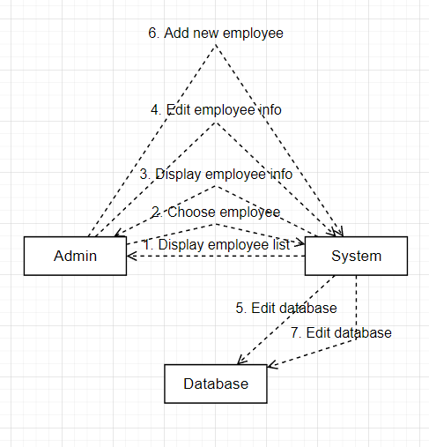

**Lawyer Edit Info**

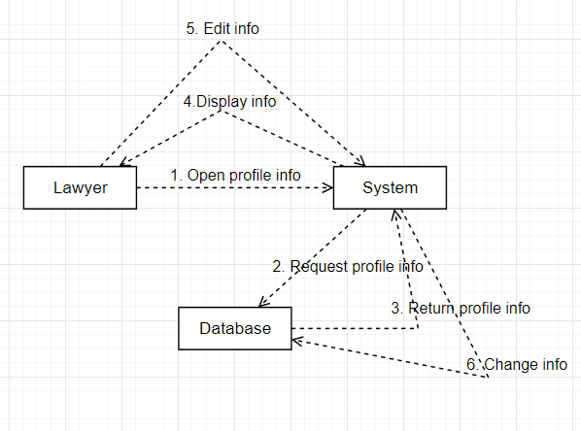

**Lawyer Login**

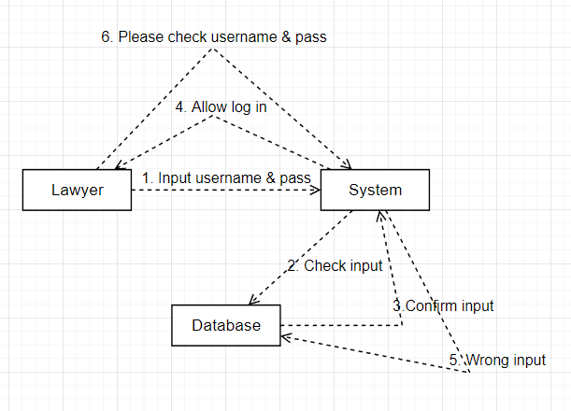

* 1. ***Class Diagram***

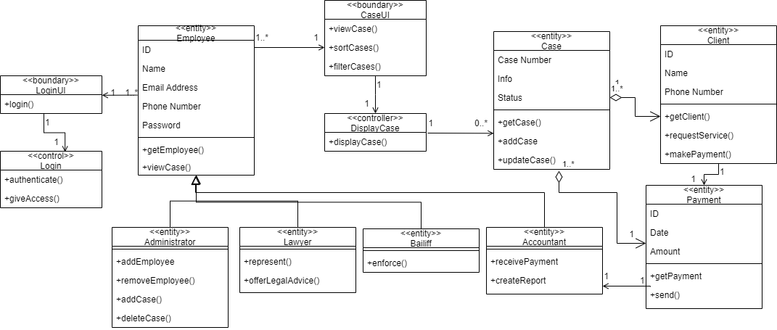

* 1. ***Object Diagram***
  2. ***Component Diagram***
  3. ***Deployment Diagram***

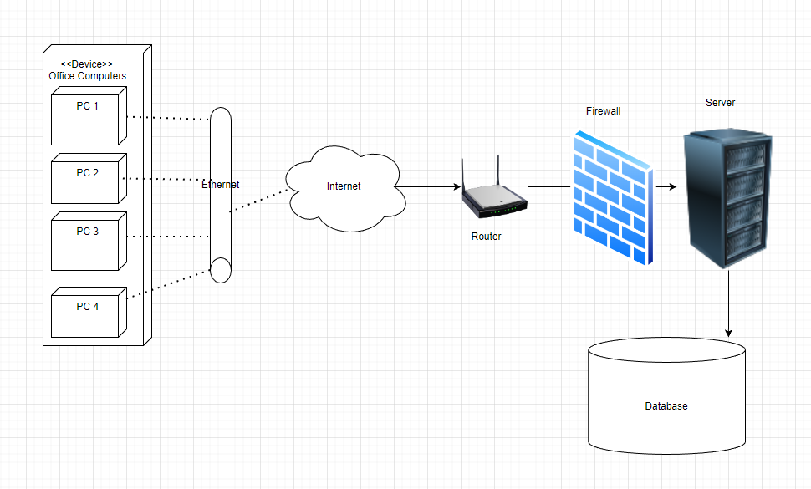

* 1. ***BPMN***

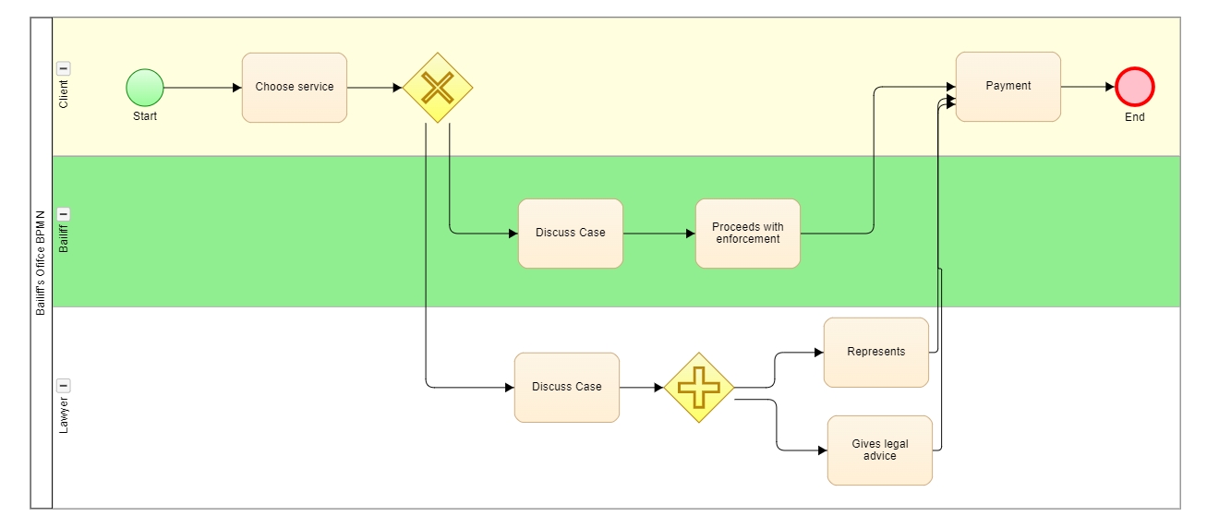

* 1. ***Design Patterns***
  2. ***Architectural Choices***

As the Bailiff’s Office Software System will be a web application, we decided to apply the client-server architectural pattern. In this pattern, there are two main components: the client, which is the service requester, and the server, which is the service provider. They communicate over the internet, on separate hardware. There is only one server, but many clients. The server is located in the Bailiff’s office, while the client refers to the web browser which the employee is using to access the web app.

The server perpetually listens for requests from the clients. When a request is received, the server processes it, and sends a response to the client. The client initiates interactions with the server to generate the services needed. Both components are linked by request/reply connectors.

A major advantage of this pattern is the central computing of data. All the files are stored in a central location (the server), therefore the data is centrally controlled.

1. **Appendix**